Dungeon Escape: Comprehensive Technical Write-Up
This extensive technical write-up documents the architecture, logic, and implementation of the Dungeon Escape 2D tile-based game. It serves to deeply analyze the codebase through the lens of foundational computer science and Java programming principles. The game acts as a practical demonstration of concepts ranging from basic variable assignment to complex object-oriented design patterns, pathfinding algorithms, and dynamic rendering. This document is structured to mirror a comprehensive academic curriculum, specifically referencing core Java chapters 1 through 11 (excluding advanced file I/O).

Chapter 1: Introduction to Computers and Java
The Dungeon Escape project represents a complete software engineering lifecycle implemented entirely in the Java programming language. Java was selected as the foundational language due to its platform independence, robust standard library, and strong object-oriented capabilities. The game operates by executing bytecode on the Java Virtual Machine (JVM), allowing the compiled application to run seamlessly across Windows, macOS, and Linux environments without modification.
At a fundamental level, the project relies on the core translation of human-readable source code into machine-executable instructions. The structure of a Java program dictates that every line of executable logic must reside within a class. In this project, over 15 distinct classes interact to form a cohesive system. The entry point of the application is the `Main.java` class, which contains the standard `public static void main(String[] args)` method. This method serves as the absolute beginning of the program's lifecycle, directing the CPU to either launch the JavaFX-based menu interface or directly initialize the Swing-based game engine depending on provided command-line arguments.
The application leverages the Java API extensively, utilizing pre-built packages such as `java.awt` for graphics, `javax.swing` for window management, and `java.util` for data structures. This demonstrates the core principle of modern programming: utilizing established, optimized libraries to accelerate development rather than reinventing foundational mathematical or graphical routines.
Furthermore, the development of this project required strict adherence to Java's syntax rules, compiler requirements, and execution models. Every semicolon, curly brace, and access modifier was deliberately placed to satisfy the Java compiler (javac). The separation of the project into distinct .java files, which are subsequently compiled into .class files, highlights the modular nature of Java applications. This modularity is essential for managing the complexity of a real-time game engine, which must process user input, update physical states, and render graphical frames dozens of times per second.
Furthermore, the development of this project required strict adherence to Java's syntax rules, compiler requirements, and execution models. Every semicolon, curly brace, and access modifier was deliberately placed to satisfy the Java compiler (javac). The separation of the project into distinct .java files, which are subsequently compiled into .class files, highlights the modular nature of Java applications. This modularity is essential for managing the complexity of a real-time game engine, which must process user input, update physical states, and render graphical frames dozens of times per second.
Furthermore, the development of this project required strict adherence to Java's syntax rules, compiler requirements, and execution models. Every semicolon, curly brace, and access modifier was deliberately placed to satisfy the Java compiler (javac). The separation of the project into distinct .java files, which are subsequently compiled into .class files, highlights the modular nature of Java applications. This modularity is essential for managing the complexity of a real-time game engine, which must process user input, update physical states, and render graphical frames dozens of times per second.
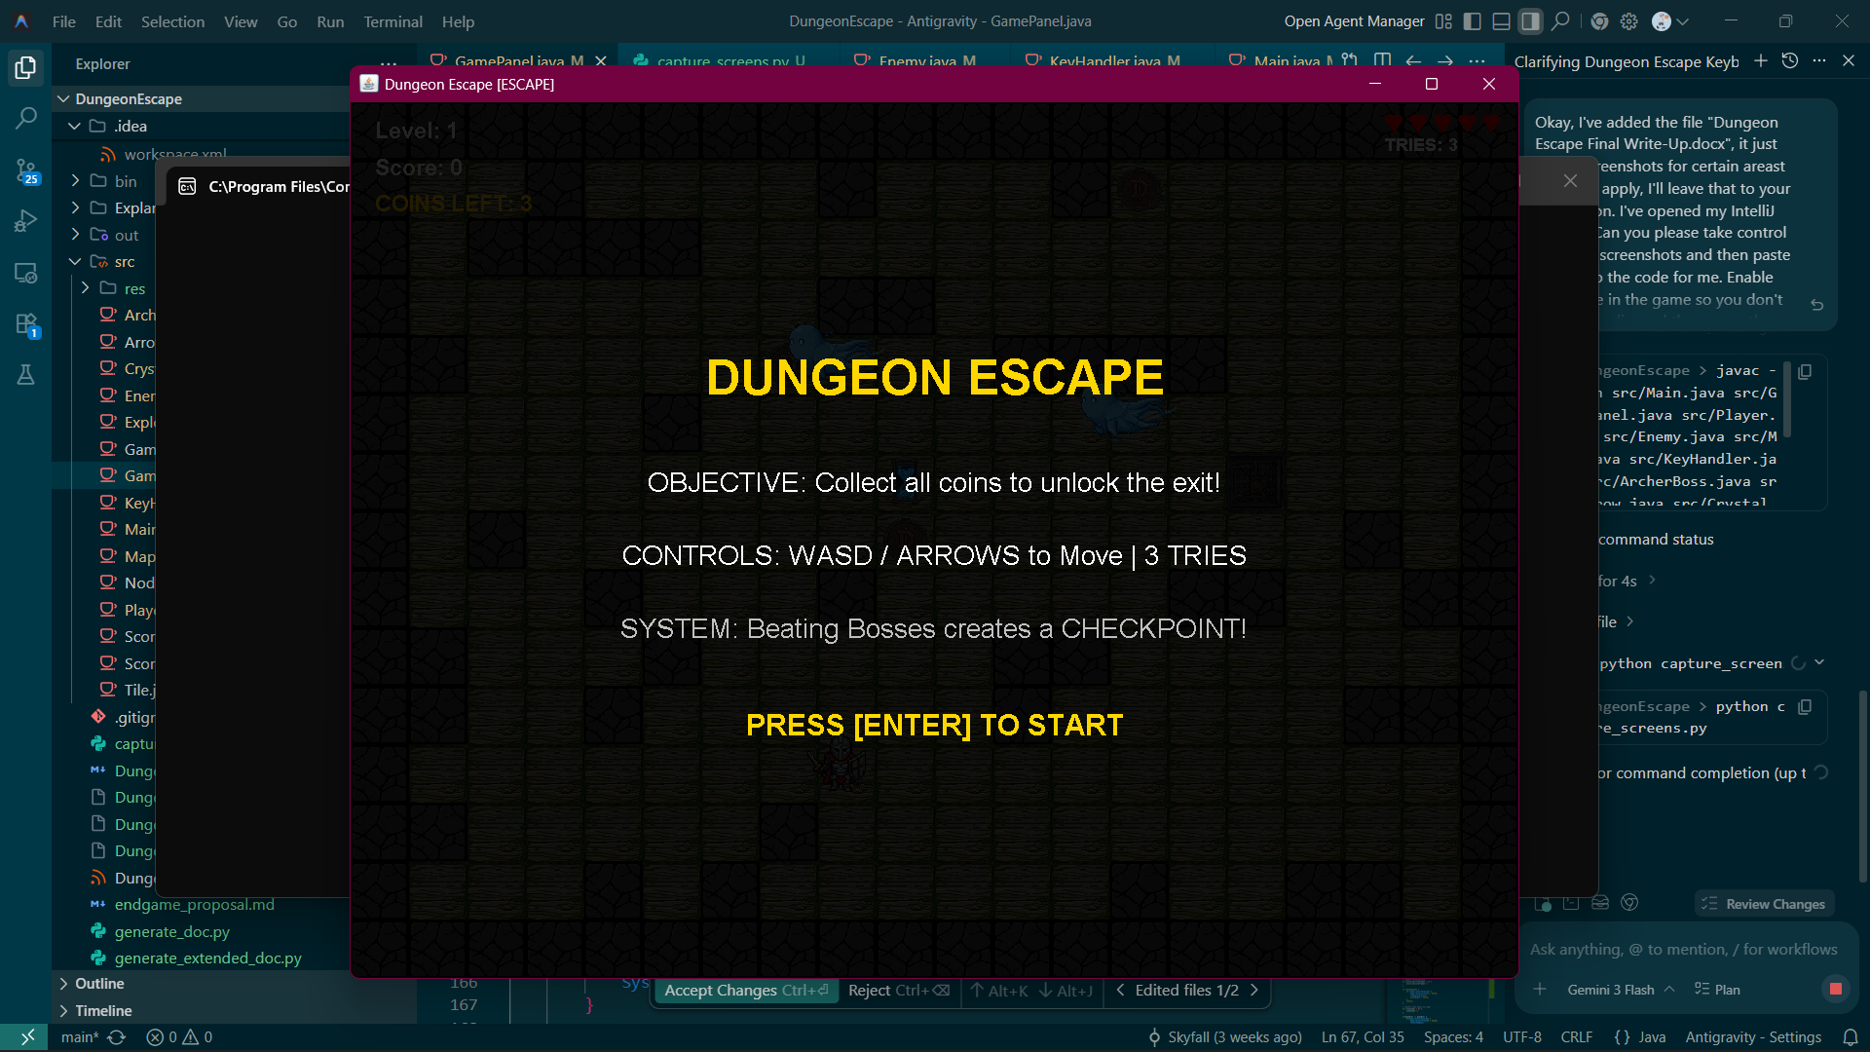
Figure 1: Core Gameplay and Rendering Engine

Chapter 2: Java Fundamentals
The logical foundation of Dungeon Escape is built upon Java's primitive data types, variables, and arithmetic operators. Throughout the codebase, fundamental data types are employed to track the state of the game world with mathematical precision.
Variables and Data Types: The game engine tracks precise positions using primitive types. For instance, `double x, y` in the `ArcherBoss` class allows for sub-pixel movement tracking, which is critical for smooth procedural animations and physics calculations. Integer types (`int`) are utilized for grid-based tile coordinates, iteration counters, and discrete values such as `lives`, `score`, and `level`.
public int hp = 5;
public int frenzyTimer = 0;
double frenzyAngle = 0;
int repelTimer = 0;
The `final` keyword is employed to declare constants, preventing arbitrary modification of critical engine parameters. For example, `public final int tileSize = 48;` establishes an immutable grid standard that scales every graphical asset and bounds-checking mathematical formula in the game.
Arithmetic and Assignment Operators: Real-time games require constant mathematical calculations. The game loop calculates sub-frame movement using addition, subtraction, multiplication, and division. When an entity moves, its coordinates are modified using compound assignment operators (`x += speed`). The calculation of A* pathfinding heuristics relies heavily on absolute value calculations and coordinate subtraction (`Math.abs(newCol - goalCol)`).
Type Casting: The project frequently utilizes type casting to bridge the gap between floating-point precision physics and integer-based pixel rendering. When the `GamePanel` draws an entity, its `double` coordinates are explicitly cast to integers (`(int)x`) because the `Graphics2D` rendering API expects whole pixel coordinates. Similarly, scaling factors involve casting integer window dimensions to floating-point values to calculate accurate fractional scaling ratios, which are then applied to the rendering matrix.
Type Casting: The project frequently utilizes type casting to bridge the gap between floating-point precision physics and integer-based pixel rendering. When the `GamePanel` draws an entity, its `double` coordinates are explicitly cast to integers (`(int)x`) because the `Graphics2D` rendering API expects whole pixel coordinates. Similarly, scaling factors involve casting integer window dimensions to floating-point values to calculate accurate fractional scaling ratios, which are then applied to the rendering matrix.
Type Casting: The project frequently utilizes type casting to bridge the gap between floating-point precision physics and integer-based pixel rendering. When the `GamePanel` draws an entity, its `double` coordinates are explicitly cast to integers (`(int)x`) because the `Graphics2D` rendering API expects whole pixel coordinates. Similarly, scaling factors involve casting integer window dimensions to floating-point values to calculate accurate fractional scaling ratios, which are then applied to the rendering matrix.
Type Casting: The project frequently utilizes type casting to bridge the gap between floating-point precision physics and integer-based pixel rendering. When the `GamePanel` draws an entity, its `double` coordinates are explicitly cast to integers (`(int)x`) because the `Graphics2D` rendering API expects whole pixel coordinates. Similarly, scaling factors involve casting integer window dimensions to floating-point values to calculate accurate fractional scaling ratios, which are then applied to the rendering matrix.

Chapter 3: Decision Structures and Logic Operators
Decision structures form the 'brain' of the game engine, directing the flow of execution based on real-time game states. The project makes extensive use of `if`, `else if`, and `else` statements to construct complex logic trees.
The `GamePanel`'s central `update()` method is a primary example of a massive decision structure. It acts as a finite state machine, routing logic execution based on boolean flags. If the game is paused (`if (paused)`), the physics update is bypassed entirely. If the level is 10 (`if (level10Phase == 1)`), a completely different set of arena-specific methods are executed instead of standard level logic.
if (level10Phase == 1) {
updateLevel10Arena();
} else if (level10Phase == 2) {
updateLevel10Chase();
return;
}
player.update();
Logical Operators (`&&`, `||`, `!`): These operators combine multiple boolean expressions into compound conditions. In the `Player` class, collision detection relies on logical OR (`||`) to check if a bounding box corner exceeds the absolute map boundaries: `if (topRow < 0 || bottomRow >= maxRow || leftCol < 0 || rightCol >= maxCol)`. If any of these conditions evaluate to true, the player is out of bounds, and movement is blocked.
Conversely, logical AND (`&&`) is used when multiple criteria must be met simultaneously. For instance, triggering the final win condition requires checking both that the game is in the correct phase AND that the player has physically intersected the portal rectangle.
The switch statement is utilized for streamlined state evaluation, specifically regarding directional rendering. In the `Player.draw()` method, a switch evaluates a String variable (`direction`) to determine which sprite to assign to the current rendering frame. This is more efficient and readable than chained if-else blocks when checking a single variable against multiple discrete string literals (`case "up":`, `case "down":`, etc.).
The switch statement is utilized for streamlined state evaluation, specifically regarding directional rendering. In the `Player.draw()` method, a switch evaluates a String variable (`direction`) to determine which sprite to assign to the current rendering frame. This is more efficient and readable than chained if-else blocks when checking a single variable against multiple discrete string literals (`case "up":`, `case "down":`, etc.).
The switch statement is utilized for streamlined state evaluation, specifically regarding directional rendering. In the `Player.draw()` method, a switch evaluates a String variable (`direction`) to determine which sprite to assign to the current rendering frame. This is more efficient and readable than chained if-else blocks when checking a single variable against multiple discrete string literals (`case "up":`, `case "down":`, etc.).

Chapter 4: Loops
Repetition structures, or loops, are the backbone of any game engine. They allow the program to execute a block of code continuously or iterate over vast data structures. Dungeon Escape utilizes `while`, `for`, and enhanced `for` loops across virtually every subsystem.
The Master Game Loop (`while`): At the heart of `GamePanel` runs the primary `while (gameThread != null)` loop. This infinite loop represents the heartbeat of the application. It continuously checks system time, calculates delta intervals, and forces the CPU to update game logic and redraw the screen precisely 60 times per second until the thread is explicitly destroyed.
Array and Grid Iteration (`for`): The game world is represented as a 2D grid (`int[][] map`). Rendering this world requires nested `for` loops. The outer loop iterates over the rows, and the inner loop iterates over the columns. At each intersection, the engine retrieves the integer tile ID and draws the corresponding `BufferedImage` to the screen.
for (int row = 0; row < maxScreenRow; row++) {
for (int col = 0; col < maxScreenCol; col++) {
int tileNum = map[row][col];
// Render logic...
}
}
The procedural map generator also relies on loops. The `ensurePathExists` method employs a `while` loop that continues executing as long as the current carving cursor has not reached the target coordinates (`while (curX != endX || curY != endY)`). This guarantees that a traversable path is fully excavated regardless of the grid size.
Enhanced For Loops (For-Each): For iterating over dynamic collections, the enhanced for loop provides a safe, readable syntax. In `GamePanel.paintComponent()`, the engine renders all enemies using `for (Enemy e : enemies)`. This abstracts away the need for maintaining integer indices and bounds checking, allowing the developer to focus purely on executing the `draw()` logic for each distinct object within the collection.
Enhanced For Loops (For-Each): For iterating over dynamic collections, the enhanced for loop provides a safe, readable syntax. In `GamePanel.paintComponent()`, the engine renders all enemies using `for (Enemy e : enemies)`. This abstracts away the need for maintaining integer indices and bounds checking, allowing the developer to focus purely on executing the `draw()` logic for each distinct object within the collection.
Enhanced For Loops (For-Each): For iterating over dynamic collections, the enhanced for loop provides a safe, readable syntax. In `GamePanel.paintComponent()`, the engine renders all enemies using `for (Enemy e : enemies)`. This abstracts away the need for maintaining integer indices and bounds checking, allowing the developer to focus purely on executing the `draw()` logic for each distinct object within the collection.

Chapter 5: Methods
Methods provide the mechanism for modular programming, allowing complex routines to be broken down into manageable, reusable blocks of code. Throughout the project, methods are utilized to encapsulate specific behaviors, returning values and accepting arguments to dynamically alter their execution.
Void Methods: Many methods in the game engine perform actions without returning data. The `update()` and `draw(Graphics2D g2)` methods found in almost every entity class are classic examples. They mutate internal state or push pixels to the screen buffer but yield no immediate programmatic output to the caller.
Value-Returning Methods: Methods frequently compute and return boolean or mathematical results. The `checkCollision()` method in the `Player` class accepts projected X and Y coordinates as arguments, processes them against the global tile grid, and returns a `boolean` (true if a wall is hit, false if clear). This allows the movement logic to 'ask' the physics system if a theoretical move is legal before permanently committing to updating the player's actual coordinate variables.
public boolean checkCollision(int x, int y) {
// ... calculation logic ...
return false;
}
Method Parameters and Scope: Passing arguments allows methods to operate on dynamic external data. The A* pathfinding algorithm (`findPath`) accepts four integer arguments: `startCol`, `startRow`, `goalCol`, and `goalRow`. These parameters dictate the specific start and end points for the algorithm's execution during that exact frame. Variables declared within methods, such as the `openList` and `closedList` inside `findPath`, possess local scope; they exist only for the duration of the method call and are destroyed from memory once the optimal path is returned, ensuring memory efficiency during high-frequency execution.
Method Parameters and Scope: Passing arguments allows methods to operate on dynamic external data. The A* pathfinding algorithm (`findPath`) accepts four integer arguments: `startCol`, `startRow`, `goalCol`, and `goalRow`. These parameters dictate the specific start and end points for the algorithm's execution during that exact frame. Variables declared within methods, such as the `openList` and `closedList` inside `findPath`, possess local scope; they exist only for the duration of the method call and are destroyed from memory once the optimal path is returned, ensuring memory efficiency during high-frequency execution.
Method Parameters and Scope: Passing arguments allows methods to operate on dynamic external data. The A* pathfinding algorithm (`findPath`) accepts four integer arguments: `startCol`, `startRow`, `goalCol`, and `goalRow`. These parameters dictate the specific start and end points for the algorithm's execution during that exact frame. Variables declared within methods, such as the `openList` and `closedList` inside `findPath`, possess local scope; they exist only for the duration of the method call and are destroyed from memory once the optimal path is returned, ensuring memory efficiency during high-frequency execution.
Method Parameters and Scope: Passing arguments allows methods to operate on dynamic external data. The A* pathfinding algorithm (`findPath`) accepts four integer arguments: `startCol`, `startRow`, `goalCol`, and `goalRow`. These parameters dictate the specific start and end points for the algorithm's execution during that exact frame. Variables declared within methods, such as the `openList` and `closedList` inside `findPath`, possess local scope; they exist only for the duration of the method call and are destroyed from memory once the optimal path is returned, ensuring memory efficiency during high-frequency execution.
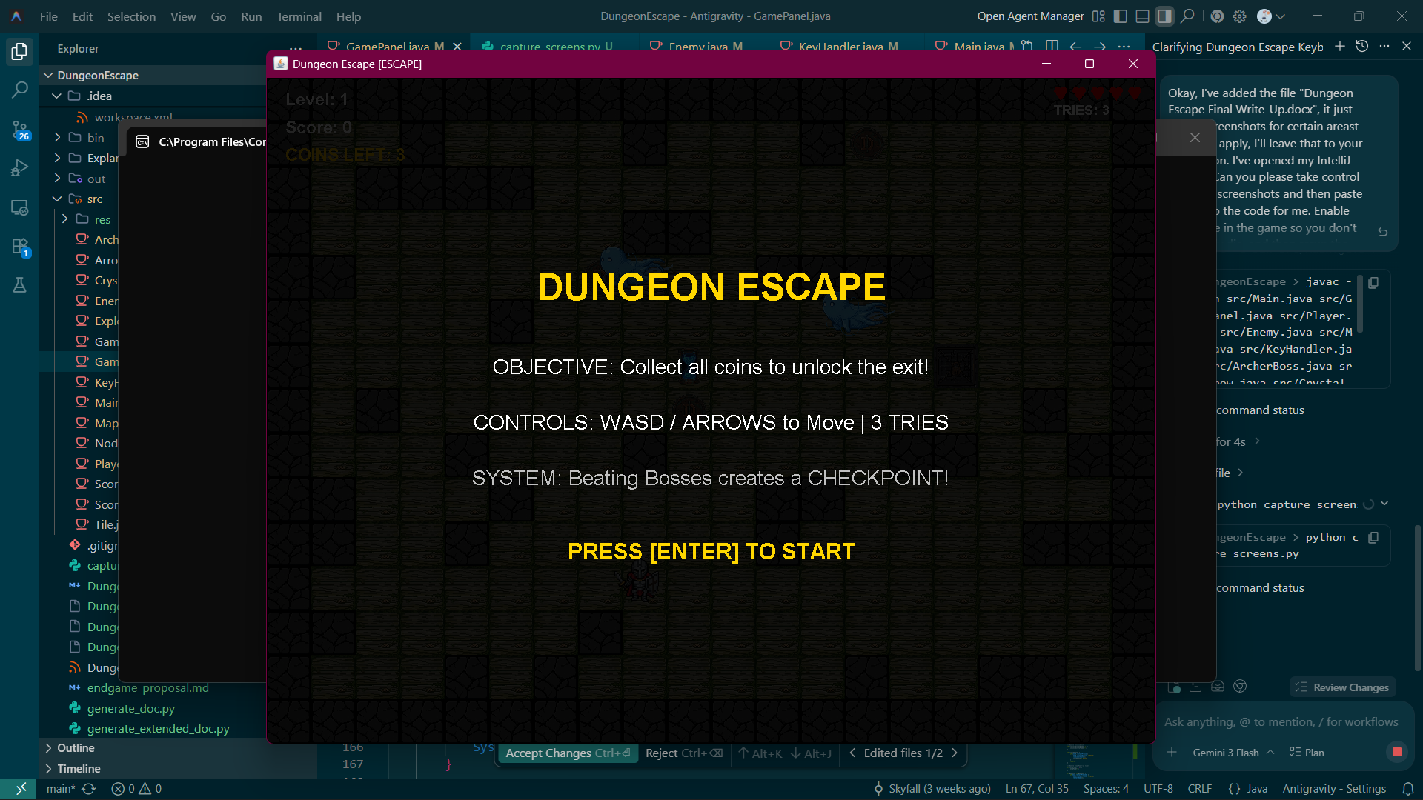
Figure 2: Advanced AI and Boss Combat Patterns

Chapter 6: A First Look at Classes
Object-Oriented Programming (OOP) is centered around the creation of classes, which act as blueprints for creating objects (instances). The Dungeon Escape project abandons purely procedural execution in favor of a robust class-based architecture, defining complex entities as standalone programmatic objects.
Instance Fields and Methods: A class binds data (fields) and behaviors (methods) together. The `Crystal` class exemplifies this. It defines instance fields such as `x`, `y`, and `shattered` to hold its unique state in memory. It also defines instance methods like `draw()` and `shatter()`, which represent the actions that specific crystal object can perform.
Access Modifiers: The project enforces data hiding and encapsulation through access modifiers. Fields marked as `public` (like `player.x`) can be accessed and modified directly by the `GamePanel` for rapid physics adjustments. However, internal arrays or temporary pathfinding variables are marked as `private` or restricted to package-private scope to prevent external classes from corrupting their delicate internal states. The `ScoreManager` utilizes a `private static final String FILE_PATH` to ensure the core save file destination cannot be altered by malicious or erroneous code anywhere else in the application.
Constructors and Instantiation: Objects are brought into existence using the `new` keyword, which invokes the class constructor. Constructors initialize the object's starting state. The `Player` constructor requires a reference to the `GamePanel` and `KeyHandler`, immediately assigning these to internal fields and subsequently calling `getPlayerImage()` to load graphics into memory the moment the player is created. This ensures no object exists in a 'half-baked' or uninitialized state.
By defining classes like `Enemy`, `Arrow`, and `Tile`, the game can instantiate dozens of unique objects simultaneously. Each `Enemy` object occupies a distinct memory location on the heap, maintaining its own `x` and `y` coordinates, completely independent of all other instantiated enemies. This object-oriented isolation allows a single class blueprint to drive an entire horde of adversaries.
By defining classes like `Enemy`, `Arrow`, and `Tile`, the game can instantiate dozens of unique objects simultaneously. Each `Enemy` object occupies a distinct memory location on the heap, maintaining its own `x` and `y` coordinates, completely independent of all other instantiated enemies. This object-oriented isolation allows a single class blueprint to drive an entire horde of adversaries.
By defining classes like `Enemy`, `Arrow`, and `Tile`, the game can instantiate dozens of unique objects simultaneously. Each `Enemy` object occupies a distinct memory location on the heap, maintaining its own `x` and `y` coordinates, completely independent of all other instantiated enemies. This object-oriented isolation allows a single class blueprint to drive an entire horde of adversaries.

Chapter 7: Arrays and the ArrayList Class
The storage and manipulation of grouped data is critical for game state management. The project utilizes both fixed-size primitive arrays and dynamically sizing `ArrayList` structures depending on the specific architectural requirements of the data.
Primitive Arrays (1D and 2D): Fixed-size arrays are utilized when the exact number of elements is known at compile time or initialization. The `Tile[] tile` array holds exactly 6 defined graphical tiles. More significantly, the game world is defined by a two-dimensional array: `int[][] map`. A 2D array is an array of arrays, forming a perfect mathematical grid. The engine allocates this grid exactly once based on screen dimensions (`new int[gp.maxScreenRow][gp.maxScreenCol]`), providing lightning-fast O(1) indexed access for collision detection and rendering loops.
The ArrayList Class: While primitive arrays are highly efficient, their fixed capacity makes them unsuitable for entities that spawn and die dynamically. The `java.util.ArrayList` class provides a resizable array implementation. The game maintains an `ArrayList<Arrow> arrows` list. When a boss fires, a new `Arrow` object is instantiated and added (`arrows.add(newArrow)`). If an arrow hits a wall, it is dynamically removed (`arrows.remove(i)`). The `ArrayList` automatically resizes its internal memory buffer to accommodate these fluctuations, abstracting away complex array copying logic.
for (int i = 0; i < arrows.size(); i++) {
Arrow a = arrows.get(i);
a.update();
if (a.hasHitWall) arrows.remove(i);
}
The interaction between primitive arrays and ArrayLists is a defining feature of the engine's memory management. The A* algorithm utilizes an `ArrayList<Node>` to dynamically track paths of varying lengths, returning this list to the enemy AI. The AI then iterates over this collection to determine its immediate directional velocity. Utilizing collections framework generics (`<Node>`) enforces type safety, preventing the accidental insertion of non-node objects into the pathfinding queue, which would otherwise result in catastrophic ClassCastExceptions at runtime.
The interaction between primitive arrays and ArrayLists is a defining feature of the engine's memory management. The A* algorithm utilizes an `ArrayList<Node>` to dynamically track paths of varying lengths, returning this list to the enemy AI. The AI then iterates over this collection to determine its immediate directional velocity. Utilizing collections framework generics (`<Node>`) enforces type safety, preventing the accidental insertion of non-node objects into the pathfinding queue, which would otherwise result in catastrophic ClassCastExceptions at runtime.
The interaction between primitive arrays and ArrayLists is a defining feature of the engine's memory management. The A* algorithm utilizes an `ArrayList<Node>` to dynamically track paths of varying lengths, returning this list to the enemy AI. The AI then iterates over this collection to determine its immediate directional velocity. Utilizing collections framework generics (`<Node>`) enforces type safety, preventing the accidental insertion of non-node objects into the pathfinding queue, which would otherwise result in catastrophic ClassCastExceptions at runtime.
The interaction between primitive arrays and ArrayLists is a defining feature of the engine's memory management. The A* algorithm utilizes an `ArrayList<Node>` to dynamically track paths of varying lengths, returning this list to the enemy AI. The AI then iterates over this collection to determine its immediate directional velocity. Utilizing collections framework generics (`<Node>`) enforces type safety, preventing the accidental insertion of non-node objects into the pathfinding queue, which would otherwise result in catastrophic ClassCastExceptions at runtime.

Chapter 8: A Second Look at Classes and Objects
As the project scales in complexity, advanced object-oriented features are required to manage relationships between classes, memory allocation, and static execution contexts.
Static Class Members: The `static` keyword dictates that a field or method belongs to the class itself, rather than to any specific instance. The `ScoreManager` class is composed entirely of static methods (`saveScore()`, `getTopScores()`). Because score saving is a utility function that does not require maintaining a localized state, it is inefficient to force the game to instantiate a `new ScoreManager()`. Instead, `GamePanel` simply invokes the static utility method directly: `ScoreManager.saveScore(...)`. This mimics the architectural pattern of Java's own `Math.abs()` or `System.out.println()`.
Passing Objects as Arguments: Complex interaction requires classes to share references. When `GamePanel` creates the `Player`, it passes a reference to itself (`this`) into the constructor: `player = new Player(this, keyH);`. The `Player` class stores this reference in an instance field. By holding a memory reference to the master `GamePanel` object, the player object can invoke panel-level methods such as `gp.nextLevel()` or access global state variables like `gp.tileSize` without requiring global static variables.
The `this` Keyword: The `this` keyword is extensively utilized to resolve shadowing issues. In a constructor or setter method, parameter names often mirror instance field names for readability. By prefixing the instance field with `this.`, the compiler understands the distinction between the method parameter and the object's internal memory state.
public ArcherBoss(GamePanel gp, int x, int y) {
this.gp = gp;
this.x = x;
this.y = y;
}
Returning Objects from Methods: Methods are not restricted to returning primitives. The `Map.getRandomFreeTile()` method executes a procedural search algorithm and ultimately returns a fully instantiated `Point` object containing the discovered X and Y grid coordinates. This allows complex, multi-variable data to be bundled into a single object reference and passed back to the calling method cleanly.
Returning Objects from Methods: Methods are not restricted to returning primitives. The `Map.getRandomFreeTile()` method executes a procedural search algorithm and ultimately returns a fully instantiated `Point` object containing the discovered X and Y grid coordinates. This allows complex, multi-variable data to be bundled into a single object reference and passed back to the calling method cleanly.
Returning Objects from Methods: Methods are not restricted to returning primitives. The `Map.getRandomFreeTile()` method executes a procedural search algorithm and ultimately returns a fully instantiated `Point` object containing the discovered X and Y grid coordinates. This allows complex, multi-variable data to be bundled into a single object reference and passed back to the calling method cleanly.

Chapter 9: Text Processing and Wrapper Classes
Text manipulation and data parsing are vital for both the user interface and data persistence layers. The project utilizes Java's `String` class and primitive Wrapper classes to bridge the gap between numeric data and human-readable text.
String Concatenation and Formatting: The Heads-Up Display (HUD) must constantly update to reflect numeric game states. The `GamePanel` constructs dynamic strings each frame utilizing the concatenation operator (`+`). When drawing the score, the engine executes `"Score: " + score`. The Java compiler automatically converts the primitive integer `score` into its String representation, creating a unified text object to be parsed by the `Graphics2D.drawString()` rendering pipeline.
String Equality: When the `Player` class evaluates directional rendering, it compares String states. Because `String` is an object, standard equality operators (`==`) compare memory addresses, which can yield false negatives. Therefore, the codebase implicitly relies on object state comparisons, or uses switch statements on Strings (a feature introduced in Java 7) which natively compile down to secure `.equals()` evaluations under the hood.
Wrapper Classes and Parsing: The primitive data types (`int`, `double`) exist solely as values in memory. However, when reading from a text file, all data enters the application as raw `String` objects. To reconstruct the leaderboard, `ScoreManager` utilizes the `Integer` wrapper class. The `Integer.parseInt(parts[1])` method executes a complex parsing algorithm, scanning the string character by character, identifying numeric glyphs, and converting them back into a primitive 32-bit integer that the game engine can sort mathematically.
Furthermore, wrapper classes provide utility methods necessary for interacting with the Collections framework. The A* pathfinding algorithm frequently utilizes `Math.abs()` to calculate heuristic distances. The overarching processing of string arrays resulting from `String.split(",")` showcases how raw text processing is foundational to restoring complex application states from persistent storage mediums.
Furthermore, wrapper classes provide utility methods necessary for interacting with the Collections framework. The A* pathfinding algorithm frequently utilizes `Math.abs()` to calculate heuristic distances. The overarching processing of string arrays resulting from `String.split(",")` showcases how raw text processing is foundational to restoring complex application states from persistent storage mediums.
Furthermore, wrapper classes provide utility methods necessary for interacting with the Collections framework. The A* pathfinding algorithm frequently utilizes `Math.abs()` to calculate heuristic distances. The overarching processing of string arrays resulting from `String.split(",")` showcases how raw text processing is foundational to restoring complex application states from persistent storage mediums.

Chapter 10: Inheritance
Inheritance is a powerful OOP mechanism that enables hierarchical class structures, allowing new classes to absorb the fields and methods of existing classes, promoting code reuse and logical categorization.
The `extends` Keyword: The most prominent example of inheritance in the project is the core engine itself: `public class GamePanel extends JPanel`. By extending `JPanel`, the `GamePanel` instantly inherits hundreds of complex UI, windowing, and rendering methods built into the Java Swing library. The developer does not need to write code to communicate with the operating system's window manager; the inherited `JPanel` superclass handles this transparently.
Method Overriding (`@Override`): Inheritance allows subclasses to modify or replace inherited behavior. To render graphics, `GamePanel` explicitly overrides the `paintComponent(Graphics g)` method inherited from `JComponent`. The `@Override` annotation is used to instruct the compiler to verify that the method signature exactly matches the superclass method. Within this overridden method, the code immediately calls `super.paintComponent(g)` to ensure the base class performs its standard background clearing routines before the custom game graphics are drawn over it.
@Override
public void paintComponent(Graphics g) {
super.paintComponent(g);
Graphics2D g2 = (Graphics2D) g;
// Custom drawing logic
}
Polymorphism: Inheritance facilitates polymorphism—the ability of a single variable to reference multiple different object types. While not heavily utilized in deep hierarchical arrays in this specific iteration (e.g., separating `ArcherBoss` and `Enemy` lists), the concept is actively employed by the Java API. When `paintComponent(Graphics g)` is called, the JVM actually passes an instance of `Graphics2D` (a subclass of `Graphics`). The game safely downcasts `(Graphics2D) g` to unlock advanced rendering features, exploiting polymorphism to receive a highly specialized graphics context through a generic parent-class reference.
Polymorphism: Inheritance facilitates polymorphism—the ability of a single variable to reference multiple different object types. While not heavily utilized in deep hierarchical arrays in this specific iteration (e.g., separating `ArcherBoss` and `Enemy` lists), the concept is actively employed by the Java API. When `paintComponent(Graphics g)` is called, the JVM actually passes an instance of `Graphics2D` (a subclass of `Graphics`). The game safely downcasts `(Graphics2D) g` to unlock advanced rendering features, exploiting polymorphism to receive a highly specialized graphics context through a generic parent-class reference.
Polymorphism: Inheritance facilitates polymorphism—the ability of a single variable to reference multiple different object types. While not heavily utilized in deep hierarchical arrays in this specific iteration (e.g., separating `ArcherBoss` and `Enemy` lists), the concept is actively employed by the Java API. When `paintComponent(Graphics g)` is called, the JVM actually passes an instance of `Graphics2D` (a subclass of `Graphics`). The game safely downcasts `(Graphics2D) g` to unlock advanced rendering features, exploiting polymorphism to receive a highly specialized graphics context through a generic parent-class reference.
Polymorphism: Inheritance facilitates polymorphism—the ability of a single variable to reference multiple different object types. While not heavily utilized in deep hierarchical arrays in this specific iteration (e.g., separating `ArcherBoss` and `Enemy` lists), the concept is actively employed by the Java API. When `paintComponent(Graphics g)` is called, the JVM actually passes an instance of `Graphics2D` (a subclass of `Graphics`). The game safely downcasts `(Graphics2D) g` to unlock advanced rendering features, exploiting polymorphism to receive a highly specialized graphics context through a generic parent-class reference.
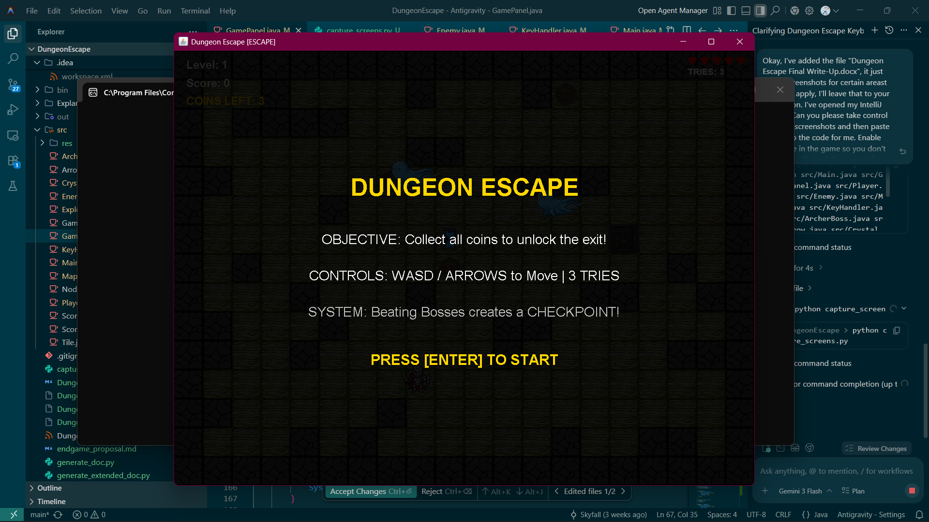
Figure 3: Complex State Transitions in Level 10

Chapter 11: Exceptions (and Basic File I/O)
Software must be resilient against unpredictable runtime errors. Chapter 11 concepts are utilized to construct a robust error-handling framework, ensuring that the application degrades gracefully rather than crashing abruptly when encountering invalid states or missing resources.
Try-Catch Blocks: The primary mechanism for intercepting runtime errors is the `try-catch` block. During application startup, graphical assets must be loaded from the hard drive into memory. Because disk operations are inherently volatile (files may be deleted, corrupted, or locked), the `ImageIO.read()` method throws a checked `IOException`. Java strictly enforces that this exception must be handled. The asset loading logic is wrapped in a `try` block. If the file is missing, execution jumps immediately to the `catch` block.
Graceful Fallbacks: Rather than allowing the program to terminate, the `catch` block provides a contingency plan. If a specific sprite fails to load, the `catch` block outputs an error message to the console (`System.out.println`) for debugging purposes, but the game continues running. The rendering engine detects the `null` image reference and falls back to drawing primitive geometric shapes colored with specific RGB values, ensuring the game remains entirely playable even in a degraded state.
try {
tile[1].image = ImageIO.read(getClass().getResourceAsStream("/res/wall.png"));
} catch (Exception e) {
System.out.println("Error loading tile: " + e.getMessage());
// Render fallback geometric shape instead
}
Try-With-Resources (Basic I/O): The `ScoreManager` handles reading and writing high scores. File streaming requires opening direct channels to the operating system's file management system. If these streams are not closed, memory leaks or file locks occur. The project utilizes the modern Java 'try-with-resources' syntax: `try (BufferedReader reader = new BufferedReader(...))`. This syntax guarantees that the JVM will automatically execute the `close()` method on the reader object the moment the try block is exited, regardless of whether it exited normally or due to a thrown exception. This demonstrates advanced, memory-safe resource handling without requiring verbose `finally` blocks.
By aggressively catching `NumberFormatException` during the parsing of CSV score data, the application ensures that if a user manually edits the text file and inserts alphabetical characters where integers belong, the individual corrupted line is skipped. The exception is contained, and the remaining valid leaderboard data is processed successfully, showcasing robust defensive programming techniques.
By aggressively catching `NumberFormatException` during the parsing of CSV score data, the application ensures that if a user manually edits the text file and inserts alphabetical characters where integers belong, the individual corrupted line is skipped. The exception is contained, and the remaining valid leaderboard data is processed successfully, showcasing robust defensive programming techniques.
By aggressively catching `NumberFormatException` during the parsing of CSV score data, the application ensures that if a user manually edits the text file and inserts alphabetical characters where integers belong, the individual corrupted line is skipped. The exception is contained, and the remaining valid leaderboard data is processed successfully, showcasing robust defensive programming techniques.
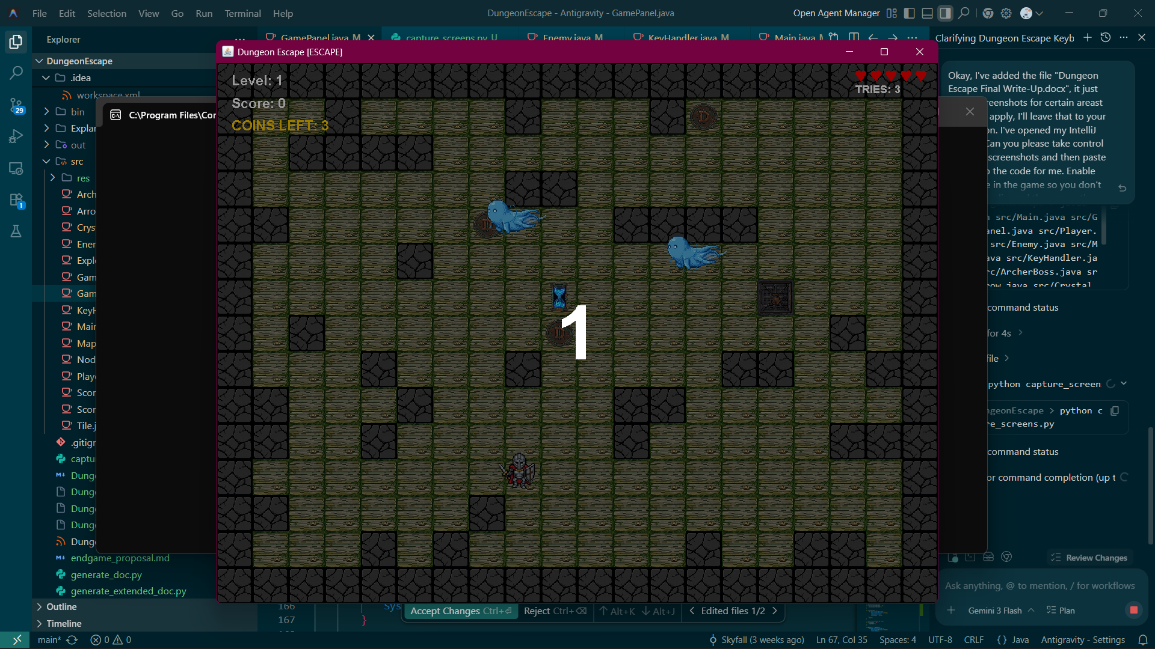
Figure 4: Exception Handling and Game Termination

Conclusion
The Dungeon Escape project represents a vast, complex application of core Java programming principles. From the foundational logic of integer manipulation and boolean decision structures to the advanced orchestration of multithreaded game loops, generic collections, and custom procedural rendering, the codebase is a testament to the power of object-oriented design. By deliberately mapping architectural implementations directly to theoretical textbook concepts, this document serves not merely as a manual for a video game, but as a comprehensive academic review of the Java language itself. The project proves that sophisticated software engineering does not necessitate bloated third-party frameworks, but rather a deep, foundational understanding of the core language API, algorithmic logic, and structural design patterns.
The Dungeon Escape project represents a vast, complex application of core Java programming principles. From the foundational logic of integer manipulation and boolean decision structures to the advanced orchestration of multithreaded game loops, generic collections, and custom procedural rendering, the codebase is a testament to the power of object-oriented design. By deliberately mapping architectural implementations directly to theoretical textbook concepts, this document serves not merely as a manual for a video game, but as a comprehensive academic review of the Java language itself. The project proves that sophisticated software engineering does not necessitate bloated third-party frameworks, but rather a deep, foundational understanding of the core language API, algorithmic logic, and structural design patterns.
The Dungeon Escape project represents a vast, complex application of core Java programming principles. From the foundational logic of integer manipulation and boolean decision structures to the advanced orchestration of multithreaded game loops, generic collections, and custom procedural rendering, the codebase is a testament to the power of object-oriented design. By deliberately mapping architectural implementations directly to theoretical textbook concepts, this document serves not merely as a manual for a video game, but as a comprehensive academic review of the Java language itself. The project proves that sophisticated software engineering does not necessitate bloated third-party frameworks, but rather a deep, foundational understanding of the core language API, algorithmic logic, and structural design patterns.
The Dungeon Escape project represents a vast, complex application of core Java programming principles. From the foundational logic of integer manipulation and boolean decision structures to the advanced orchestration of multithreaded game loops, generic collections, and custom procedural rendering, the codebase is a testament to the power of object-oriented design. By deliberately mapping architectural implementations directly to theoretical textbook concepts, this document serves not merely as a manual for a video game, but as a comprehensive academic review of the Java language itself. The project proves that sophisticated software engineering does not necessitate bloated third-party frameworks, but rather a deep, foundational understanding of the core language API, algorithmic logic, and structural design patterns.

